**Thank you for purchase**

**How to place/change images in Photoshop**

1) Choose and open your favorite psd file in photoshop.

2) See open example Psd file and layer panel on right side.

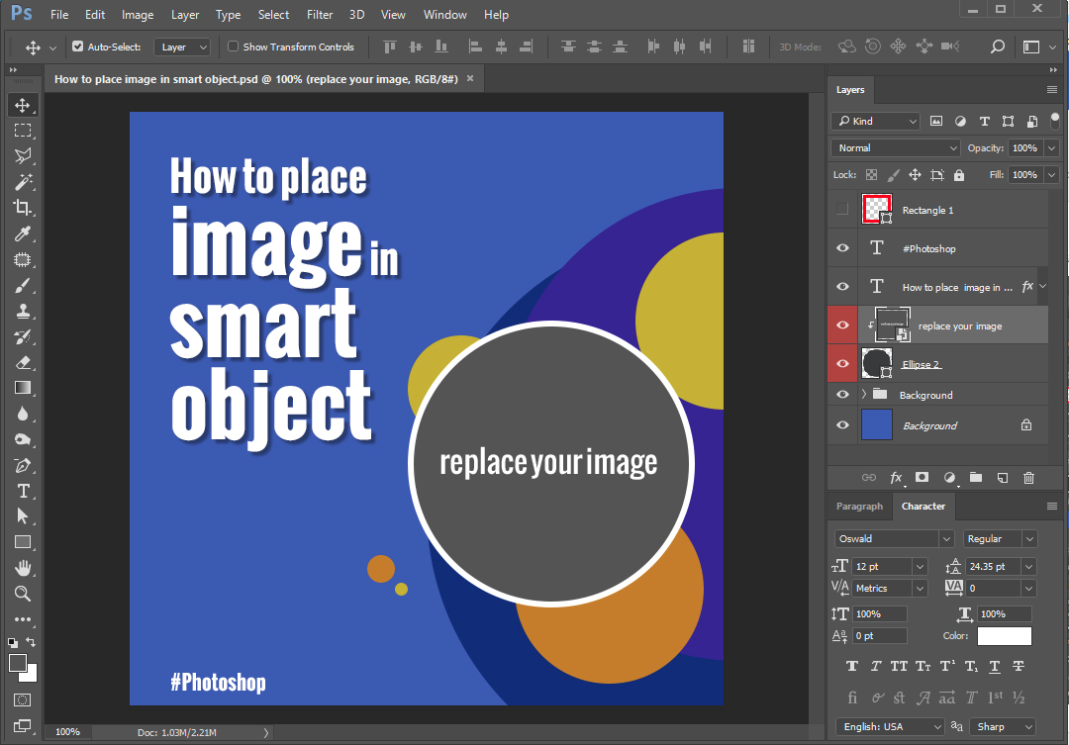

3) Right click on targeted “shape/smart object” you have to place image into. Choose the layer on to appear popup menu ( *for example “replace your image*”). Now you can see the layer panel which layer you selected.

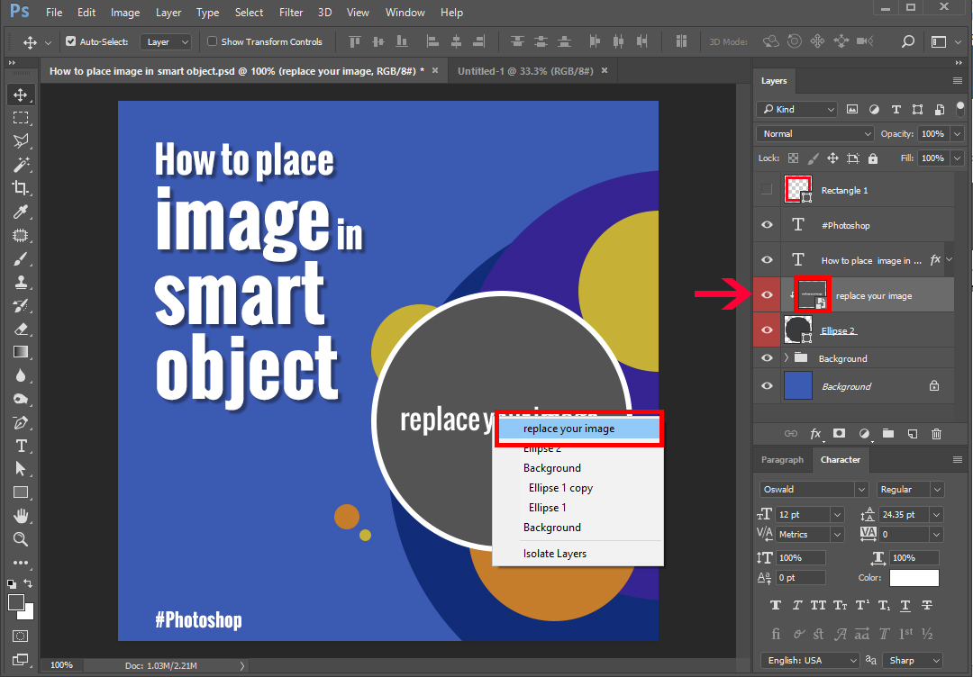

4) Then **Double click** the **Smart Object's thumbnail** in the Layer's panel to Edit the Contents of a Smart Object.

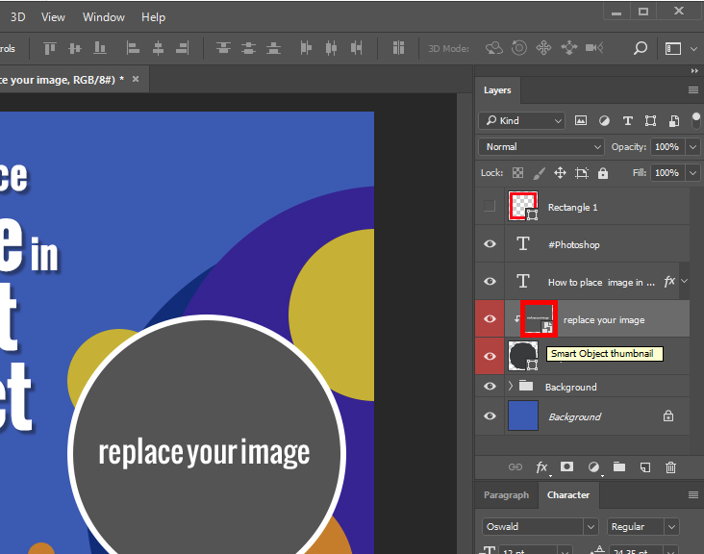

or right click on targeted layer in layer panel and choose “Edit Contents” on to appear popup menu.

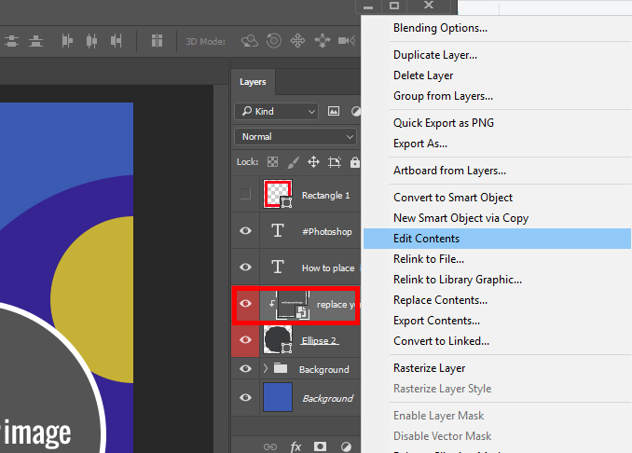

5) Smart Object open as a separate file with .psb file format, For example : file name “Ellipse 2.psb”. look like below.

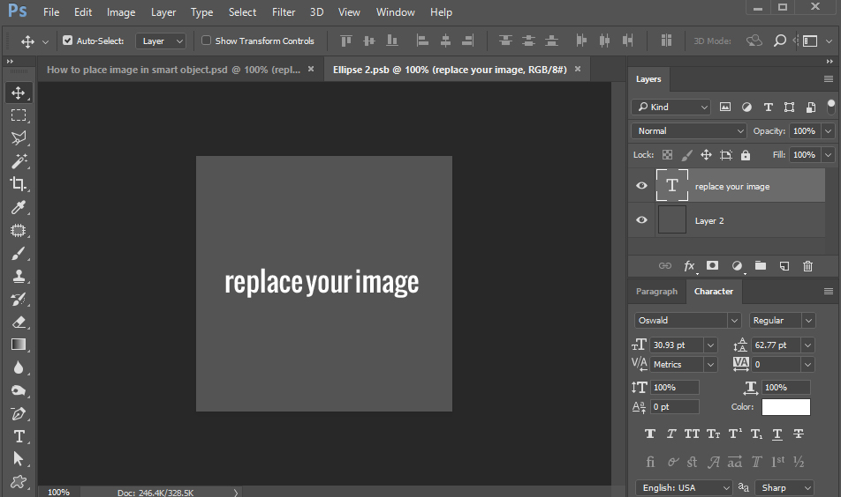

6) Then open / drag your image which want to place.

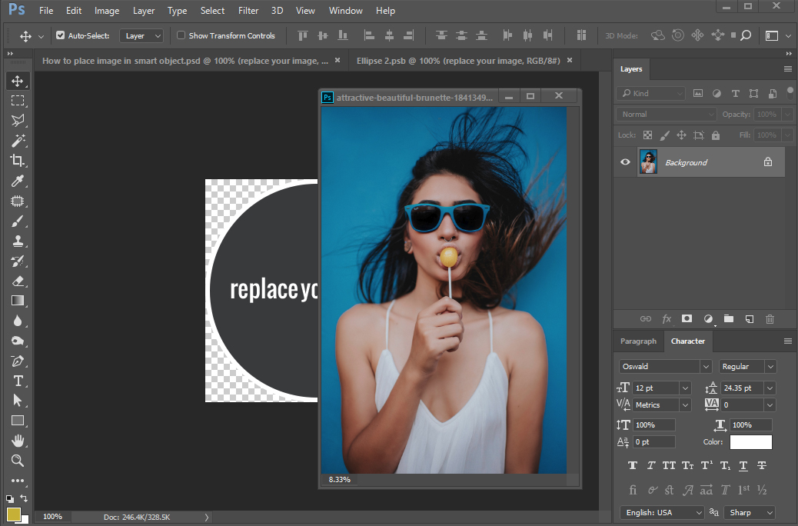

7) Set/place image as a top layer in layer panel.

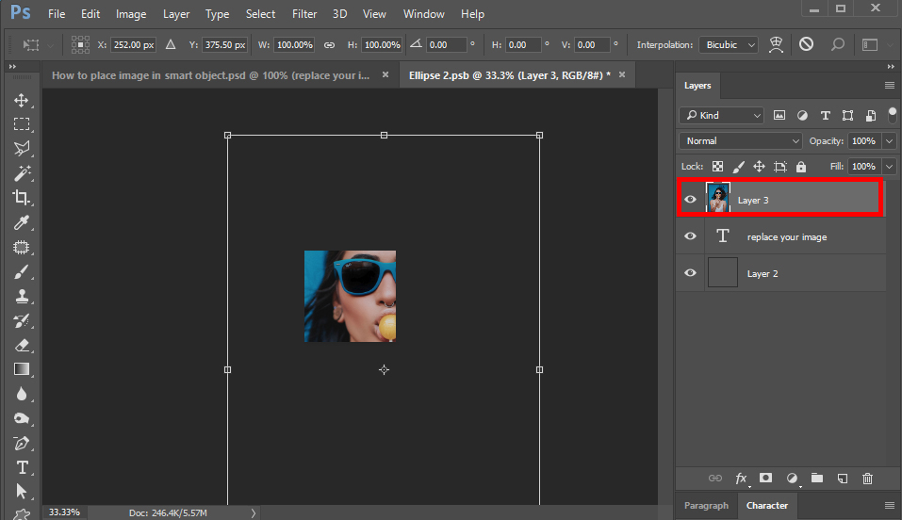

8) Adjust image size small or big according to you with transform tool/controls.

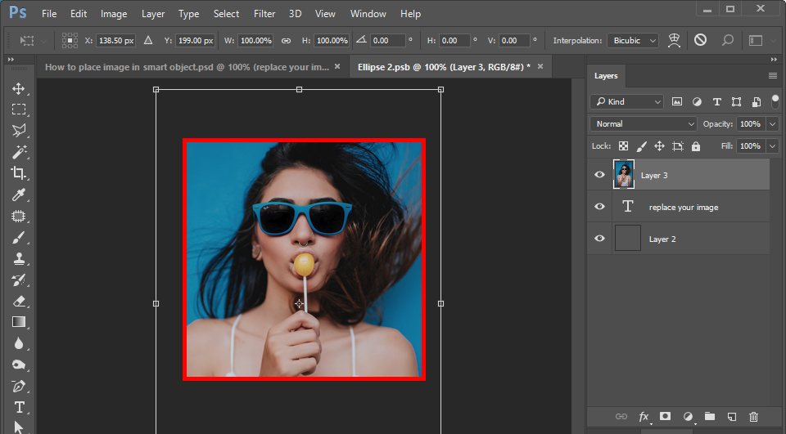

9) Then save a file, it is very important for result. And Press “X icon” you see icon next to “.psb” on file header for exit to file.

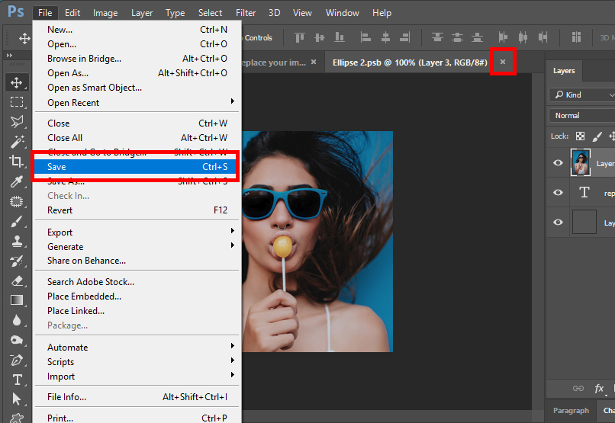

10) After return to main file “save” your xxxxxxx.psd file. You have done image editing…. **cheers**

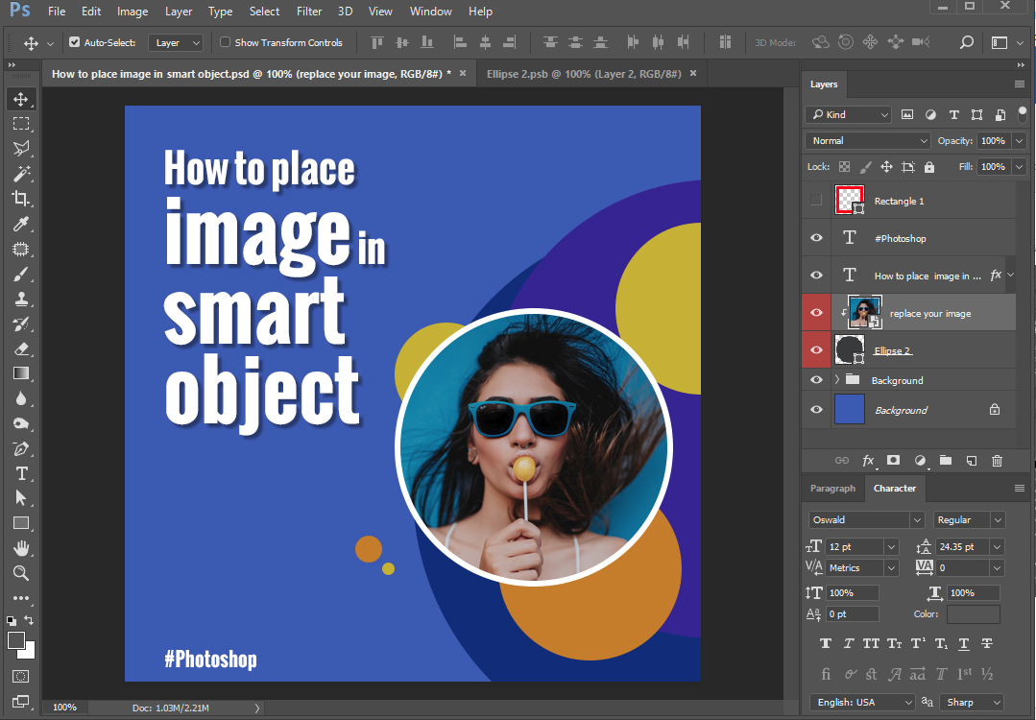

**For place/replace/edit other images.**

You can place or edit other images in to “Smart Object”. Repeat above mentioned presses.

Thanks.

**Webwall**